
TECH MAHINDRA STOCK ANALYSIS
SQL PROJECT + Power BI

Prepared by:
Sameer Siddiqui
Tools Used:
• PostgreSQL
• Excel
• Power BI working
Project Type: Exploratory Data Analysis (ED ) Date: 9/02/2026
Introduction:
This project analyzes Tech Mahindra stock data using SQL. The objective of the project is to understand stock price movements, trading volume, market trends, and investor behavior by using various SQL functions and analytical techniques. The project includes aggregate functions, ranking functions, window functions, common table expressions (CTEs), and conditional statements.
QUERY 01 – HIGHEST CLOSING PRICE
Purpose:
Identify the highest closing price.
SQL:
SELECT MAX("CLOSE") AS highest_closing_price
FROM stock_data;
Result:
1768.40
Observation:
The highest closing price recorded was 1768.40.
Skills:
SELECT, MAX(), AS

QUERY 02 – LOWEST CLOSING PRICE
Purpose:
Identify the lowest closing price recorded in the dataset.
Result:
1331.70
Observation:
The lowest closing price recorded during the selected period was 1331.70.
Business Interpretation:
This value represents the weakest closing performance observed in the dataset.
Skills Used:
SELECT, MIN(), AS, Aggregate Functions
QUERY 03 – AVERAGE CLOSING PRICE
Purpose:
Calculate the average closing price recorded in the dataset.
Result:
1492.98
Observation:
The average closing price recorded during the selected period was 1492.98.
Business Interpretation:
This value represents the average market closing value observed during the selected period.
Skills Used:
SELECT, AVG(), ROUND(), AS
QUERY 04 – HIGHEST STOCK PRICE
Purpose:
Identify the highest stock price recorded in the dataset.
Result:
1854.00
Observation:
The highest stock price recorded during the selected period was 1854.00.
Business Interpretation:
This value represents the highest price reached by Tech Mahindra stock during the selected period.
Skills Used:
SELECT, MAX(), AS
QUERY 05 – LOWEST STOCK PRICE
Purpose:
Identify the lowest stock price recorded in the dataset.
Result:
1304.10
Observation:
The lowest stock price recorded during the selected period was 1304.10.
Business Interpretation:
This value represents the minimum price reached by Tech Mahindra stock during the selected period.
Skills Used:
SELECT, MIN(), AS
QUERY 06 – HIGHEST TRADING VOLUME
Purpose:
Identify the highest trading volume recorded in the dataset.
Result:
11668801.00
Observation:
The highest trading volume recorded during the selected period was 11668801.00.
Business Interpretation:
This value represents the highest number of shares traded during the selected period. A high trading volume generally indicates increased market activity and strong investor participation.
Skills Used:
SELECT, MAX(), AS
QUERY 07 – LOWEST TRADING VOLUME
Purpose:
Identify the lowest trading volume recorded in the dataset.
Result:
114229.00
Observation:
The lowest trading volume recorded during the selected period was 114229.00.
Business Interpretation:
This value represents the lowest number of shares traded during the selected period. Lower trading volume generally indicates reduced market activity and lower investor participation.
Skills Used:
SELECT, MIN(), AS
QUERY 08 – AVERAGE TRADING VOLUME
Purpose:
Calculate the average trading volume recorded in the dataset.
Result:
2190817.16
Observation:
The average trading volume recorded during the selected period was 2190817.16.
Business Interpretation:
This value represents the average number of shares traded during the selected period and provides an indication of the overall trading activity of Tech Mahindra stock.
Skills Used:
SELECT, AVG(), ROUND(), AS
QUERY 09 – DAILY PRICE MOVEMENT ANALYSIS
Purpose:
Calculate the difference between the highest price and the lowest price for each trading day.
Result:
The query returned 246 records.
Top Results:
Date | High | Low | Daily Movement
2026-02-03 | 1854.00 | 1712.70 | 141.30
2026-04-22 | 1502.80 | 1404.10 | 98.70
2026-02-24 | 1423.20 | 1335.30 | 87.90
2026-06-03 | 1554.70 | 1467.60 | 87.10
Observation:
The largest daily price movement recorded during the selected period was 141.30.
Business Interpretation:
Large daily price movements indicate higher market volatility and increased trading activity.
Skills Used:
SELECT, ROUND(), ORDER BY, DESC, arithmetic operators (-)
QUERY 10 – OPENING PRICE VS CLOSING PRICE
Purpose:
Compare the opening price and closing price for each trading day.
Result:
The query returned 246 records.
Top Results:
Date | Open Price | Closing Price | Price Difference
2026-01-16 | 1600.00 | 1670.50 | 70.50
2026-05-18 | 1363.70 | 1430.00 | 66.30
2026-07-13 | 1444.20 | 1504.50 | 60.30
2026-06-19 | 1350.00 | 1409.60 | 59.60
2026-02-13 | 1482.60 | 1534.40 | 51.80
Observation:
The largest difference between the opening price and the closing price was 70.50.
Business Interpretation:
The results indicate that the stock experienced significant positive price movements on certain trading days. Positive values show that the closing price was higher than the opening price.
Skills Used:
SELECT, ROUND(), ORDER BY, DESC, Arithmetic Operators (-)
QUERY 11 – MONTHLY AVERAGE CLOSING PRICE
Purpose:
Calculate the average closing price for each month.
Result:
The query returned 12 records.
Top Results:
Month | Average Closing Price
January | 1657.76
December | 1585.20
February | 1542.20
July | 1518.76
September | 1492.37
Observation:
January recorded the highest average closing price, followed by December and February.
Business Interpretation:
The results indicate that stock performance varied from month to month. January showed the strongest performance, while other months displayed comparatively lower average closing prices.
Skills Used:
SELECT, AVG(), ROUND(), GROUP BY, ORDER BY, DESC
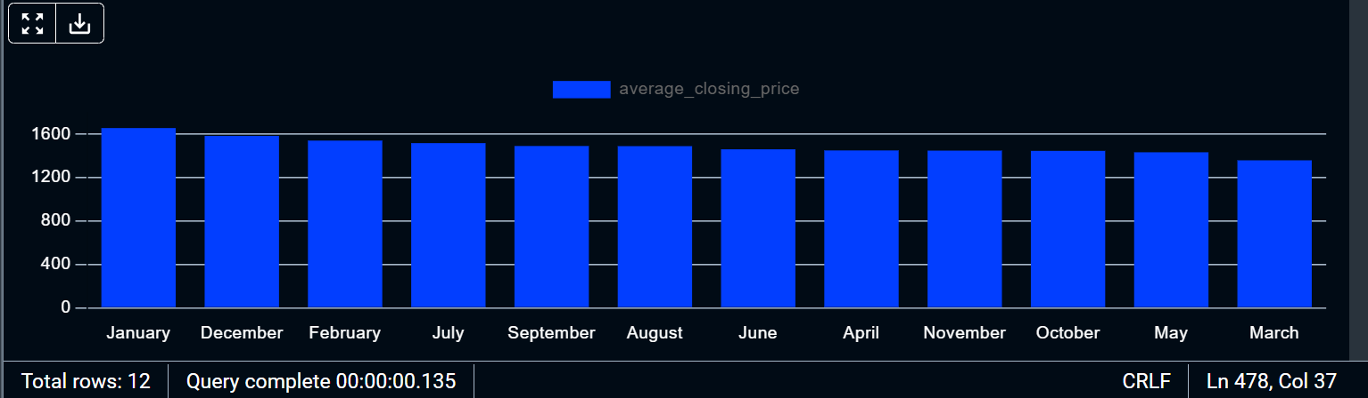
– MONTHLY AVERAGE CLOSING PRICE
QUERY 12 – MONTHLY TRADING VOLUME
Purpose:
Calculate the total trading volume for each month.
Result:
The query returned 12 records.
Top Results:
Month | Total Trading Volume
July | 65060355.00
June | 56239931.00
February | 54641806.00
April | 53076538.00
November | 44283123.00
Observation:
July recorded the highest trading volume, followed by June and February.
Business Interpretation:
The results indicate that investor activity was highest during July. Higher trading volumes generally indicate stronger market participation and increased buying and selling activity.
Skills Used:
SELECT, SUM(), GROUP BY, ORDER BY, DESC
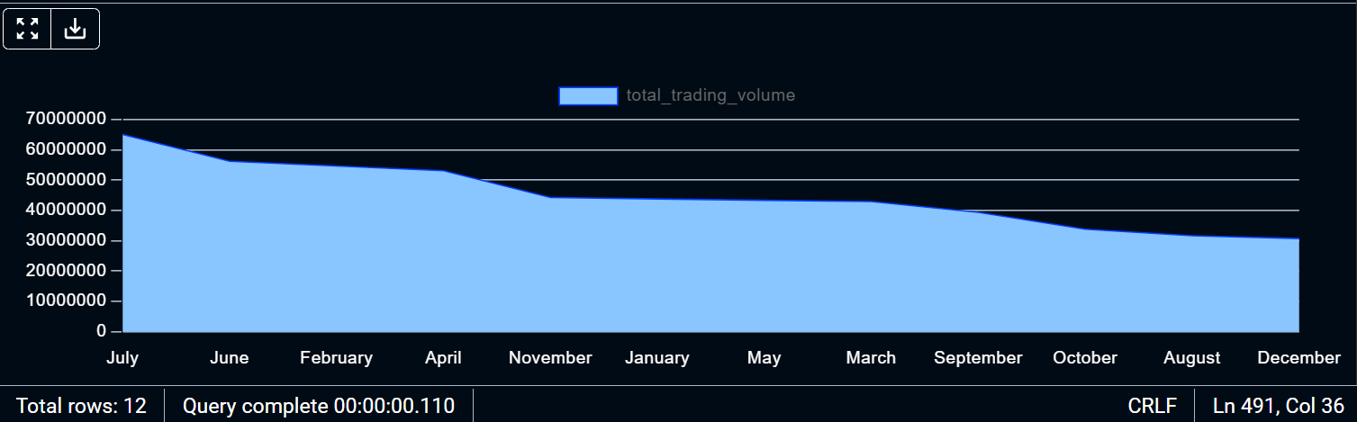
– MONTHLY TRADING VOLUME
QUERY 13 – QUARTERLY AVERAGE CLOSING PRICE
Purpose:
Calculate the average closing price for each quarter.
Result:
The query returned four records.
Results:
Quarter | Average Closing Price
Q1 | 1523.09
Q3 | 1501.44
Q4 | 1497.03
Q2 | 1449.67
Observation:
The first quarter (Q1) recorded the highest average closing price of 1523.09, while the second quarter (Q2) recorded the lowest average closing price of 1449.67.
Business Interpretation:
The results indicate that Tech Mahindra stock performed best during the first quarter. The lower average closing price observed in the second quarter suggests comparatively weaker performance during that period.
Skills Used:
SELECT, AVG(), ROUND(), GROUP BY, ORDER BY, DESC
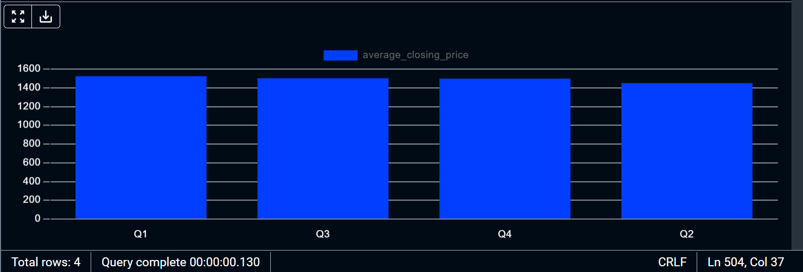
– QUARTERLY AVERAGE CLOSING PRICE

QUERY 14 – QUARTERLY TRADING VOLUME
Purpose:
Calculate the total trading volume for each quarter.
Result:
The query returned four records.
Results:
Quarter | Total Trading Volume
Q2 | 152672725.00
Q1 | 141368793.00
Q3 | 136053671.00
Q4 | 108845833.00
Observation:
The second quarter (Q2) recorded the highest trading volume of 152672725.00, while the fourth quarter (Q4) recorded the lowest trading volume of 108845833.00.
Business Interpretation:
The results indicate that investor activity was highest during the second quarter. Increased trading volume generally reflects stronger market participation and greater buying and selling activity.
Skills Used:
SELECT, SUM(), GROUP BY, ORDER BY, DESC
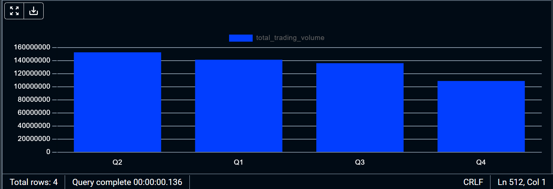
– QUARTERLY TRADING VOLUME
QUERY 15 – HIGHEST VWAP (VOLUME WEIGHTED AVERAGE PRICE)
Purpose:
Identify the highest Volume Weighted Average Price (VWAP) recorded in the dataset.
Result:
1759.86
Observation:
The highest VWAP recorded during the selected period was 1759.86.
Business Interpretation:
This value indicates the highest average price at which the stock was traded during the trading day, taking both price and trading volume into account. A high VWAP often reflects strong buying activity and positive market sentiment.
Skills Used:
SELECT, MAX(), AS
QUERY 16 – LOWEST VWAP (VOLUME WEIGHTED AVERAGE PRICE)
Purpose:
Identify the lowest Volume Weighted Average Price (VWAP) recorded in the dataset.
Result:
1325.23
Observation:
The lowest VWAP recorded during the selected period was 1325.23.
Business Interpretation:
This value indicates the lowest average price at which the stock was traded during the selected period after considering both price and trading volume. A lower VWAP may indicate weaker market performance and lower buying activity.
Skills Used:
SELECT, MIN(), AS
QUERY 17 – HIGHEST NUMBER OF TRADES
Purpose:
Identify the highest number of trades recorded in the dataset.
Result:
311306.00
Observation:
The highest number of trades recorded during the selected period was 311306.00.
Business Interpretation:
This value represents the period with the highest trading activity. A larger number of trades generally indicates strong investor interest, increased liquidity, and greater market participation.
Skills Used:
SELECT, MAX(), AS
QUERY 18 – LOWEST NUMBER OF TRADES
Purpose:
Identify the lowest number of trades recorded in the dataset.
Result:
6606.00
Observation:
The lowest number of trades recorded during the selected period was 6606.00.
Business Interpretation:
This value represents the period with the lowest trading activity. A lower number of trades generally indicates reduced investor participation and lower market liquidity.
Skills Used:
SELECT, MIN(), AS
QUERY 19 – YEARLY PERFORMANCE ANALYSIS
Purpose:
Calculate the average closing price for each year.
Result:
The query returned two records.
Results:
Year | Average Closing Price
2025 | 1494.92
2026 | 1491.59
Observation:
The average closing price in 2025 was 1494.92, while the average closing price in 2026 was 1491.59. The difference between the two years was relatively small.
Business Interpretation:
The results indicate that Tech Mahindra stock maintained relatively stable performance during the selected period. The slight decrease in the average closing price during 2026 may indicate changing market conditions and investor sentiment.
Skills Used:
SELECT, AVG(), ROUND(), GROUP BY, ORDER BY
QUERY 20 – HIGHEST 52-WEEK HIGH
Purpose:
Identify the highest value recorded in the 52-week high column.
Result:
1854.00
Observation:
The highest value recorded during the selected period was 1854.00.
Business Interpretation:
This value represents the highest price achieved by Tech Mahindra stock during the 52-week period. Reaching a 52-week high often indicates strong market performance, increased investor confidence, and positive momentum.
Skills Used:
SELECT, MAX(), AS
QUERY 21 – LOWEST 52-WEEK LOW
Purpose:
Identify the lowest value recorded in the 52-week low column.
Result:
1209.40
Observation:
The lowest value recorded during the selected period was 1209.40.
Business Interpretation:
This value represents the lowest price reached by Tech Mahindra stock during the 52-week period. Lower prices generally indicate weaker market performance, changes in investor sentiment, or broader market fluctuations.
Skills Used:
SELECT, MIN(), AS
QUERY 22 – RANK DAILY PRICE MOVEMENTS
Purpose:
Rank trading days according to daily price movement to identify periods of high market volatility.

Result:
The query returned 246 records.

Top Results:
Rank | High | Low | Daily Movement
1 | 1854.00 | 1712.70 | 141.30
2 | 1502.80 | 1404.10 | 98.70
3 | 1423.20 | 1335.30 | 87.90
4 | 1554.70 | 1467.60 | 87.10
5 | 1548.00 | 1464.40 | 83.60

Observation:
The largest daily price movement recorded during the selected period was 141.30. The ranking function allowed us to identify the most volatile trading days in the dataset.

Business Interpretation:
Days with higher price movements generally indicate greater market volatility, increased trading activity, and stronger investor participation. Analysts often use this information to identify unusual market behavior and significant price fluctuations.

Skills Used:
- SELECT
- RANK()
- OVER()
- ORDER BY
- DESC
- Arithmetic operators (-)
QUERY 23 – ROW NUMBER ANALYSIS
Purpose:
Assign a unique row number to every record based on the closing price in descending order.

Result:
The query returned 246 records.

Top Results:
Row Number | Date | Closing Price
1 | 2026-01-29 | 1768.40
2 | 2026-01-28 | 1762.90
3 | 2026-01-27 | 1745.10
4 | 2026-01-30 | 1743.10
5 | 2026-02-02 | 1724.00

Observation:
The highest closing price received the first rank, while the remaining records were arranged in descending order according to their closing price values.

Business Interpretation:
The ROW_NUMBER() function assigns a unique number to each record, making it easier to identify the top-performing records and analyze ranking patterns within the dataset.

Skills Used:
- SELECT
- ROW_NUMBER()
- OVER()
- ORDER BY
- DESC

QUERY 24 – DENSE_RANK() ANALYSIS
Purpose:
Assign rankings to records according to their closing prices while ensuring that duplicate values receive the same rank.

Result:
The query returned 246 records.

Top Results:
Dense Rank | Date | Closing Price
1 | 2026-01-29 | 1768.40
2 | 2026-01-28 | 1762.90
3 | 2026-01-27 | 1745.10
4 | 2026-01-30 | 1743.10
5 | 2026-02-02 | 1724.00

Observation:
The records were ranked according to their closing prices. Unlike the ROW_NUMBER() function, DENSE_RANK() assigns the same rank to identical values and does not leave gaps in the ranking sequence.

Business Interpretation:
This function helps analysts identify top-performing periods and compare records based on their relative performance. It is widely used in financial analysis, business intelligence reporting, and dashboard development.

Skills Used:
- SELECT
- DENSE_RANK()
- OVER()
- ORDER BY
- DESC
QUERY 25 – LAG() ANALYSIS
Purpose:
Compare the closing price of the current day with the closing price of the previous trading day.

Result:
The query returned 246 records.

Top Results:
Date | Closing Price | Previous Day Close | Price Change
2025-08-01 | 1438.80 | NULL | NULL
2025-08-04 | 1475.00 | 1438.80 | 36.20
2025-08-05 | 1485.40 | 1475.00 | 10.40
2025-08-06 | 1459.00 | 1485.40 | -26.40
2025-08-07 | 1482.00 | 1459.00 | 23.00

Observation:
The LAG() function retrieved the closing price from the previous trading day. Positive values indicate an increase in the stock price, while negative values indicate a decline.

Business Interpretation:
This analysis helps investors and analysts understand daily price fluctuations and identify short-term market trends. It is widely used to measure stock performance and monitor market behavior.

Skills Used:
- SELECT
- LAG()
- OVER()
- ORDER BY
- ROUND()
QUERY 26 – LEAD() ANALYSIS
Purpose:
Compare the current day's closing price with the next day's closing price.

Result:
The query returned 246 records.

Top Results:
Date | Closing Price | Next Day Close | Next Day Change
2025-08-01 | 1438.80 | 1475.00 | 36.20
2025-08-04 | 1475.00 | 1485.40 | 10.40
2025-08-05 | 1485.40 | 1459.00 | -26.40
2025-08-06 | 1459.00 | 1482.00 | 23.00
2025-08-07 | 1482.00 | 1480.40 | -1.60

Observation:
The LEAD() function retrieved the closing price of the following trading day. Positive values indicate an increase in the stock price, while negative values indicate a decline in price.

Business Interpretation:
This analysis helps analysts anticipate short-term market movements and identify patterns in stock price behavior. The LEAD() function is widely used in financial forecasting and trend analysis.

Skills Used:
- SELECT
- LEAD()
- OVER()
- ORDER BY
- ROUND()
QUERY 27 – CASE STATEMENT ANALYSIS
Purpose:
Categorize stock performance by comparing the opening price with the closing price.

Result:
The query returned 246 records.

Top Results:
Date | Opening Price | Closing Price | Status
2026-07-31 | 1620.00 | 1651.30 | Price Increased
2026-07-30 | 1649.00 | 1669.00 | Price Increased
2026-07-29 | 1661.00 | 1644.20 | Price Decreased
2026-07-28 | 1599.00 | 1635.20 | Price Increased
2026-07-27 | 1576.00 | 1575.00 | Price Decreased

Observation:
The CASE statement divided the records into different categories according to the relationship between the opening price and the closing price.
- If the closing price was greater than the opening price, the stock price increased.
- If the closing price was lower than the opening price, the stock price decreased.
- If both values were equal, the stock price remained stable.

Business Interpretation:
This analysis helps analysts understand market sentiment and daily stock performance. The CASE statement is one of the most powerful SQL tools because it converts numerical values into meaningful categories.

Skills Used:
- SELECT
- CASE
- WHEN
- THEN
- ELSE
- END

QUERY 28 – CTE ANALYSIS
Purpose:
Identify the top five highest closing prices recorded in the dataset.

Result:
The query returned the five highest closing prices.

Top Results:
Rank | Date | Closing Price
1 | 2026-01-29 | 1768.40
2 | 2026-01-28 | 1762.90
3 | 2026-01-27 | 1745.10
4 | 2026-01-30 | 1743.10
5 | 2026-02-02 | 1724.00

Observation:
The Common Table Expression (CTE) was used to create a temporary result set that made the query easier to read and manage.

Business Interpretation:
CTEs are widely used to simplify complex queries, improve readability, and organize large datasets into smaller sections for analysis.

Skills Used:
- WITH
- CTE
- SELECT
- ORDER BY
- LIMIT

QUERY 29 – RUNNING TOTAL ANALYSIS
Purpose:
Calculate the cumulative trading volume over time.

Result:
The query returned 246 records.

Top Results:
Date | Volume | Cumulative Volume
2025-08-01 | 1620011.00 | 1620011.00
2025-08-04 | 1581473.00 | 3201484.00
2025-08-05 | 2929677.00 | 6131161.00
2025-08-06 | 1039973.00 | 7171134.00
2025-08-07 | 1587489.00 | 8758623.00

Observation:
The cumulative value increased continuously because each day's trading volume was added to the previous total.

Business Interpretation:
Running totals help analysts understand long-term growth patterns and monitor changes over time.

Skills Used:
- SUM()
- OVER()
- ORDER BY

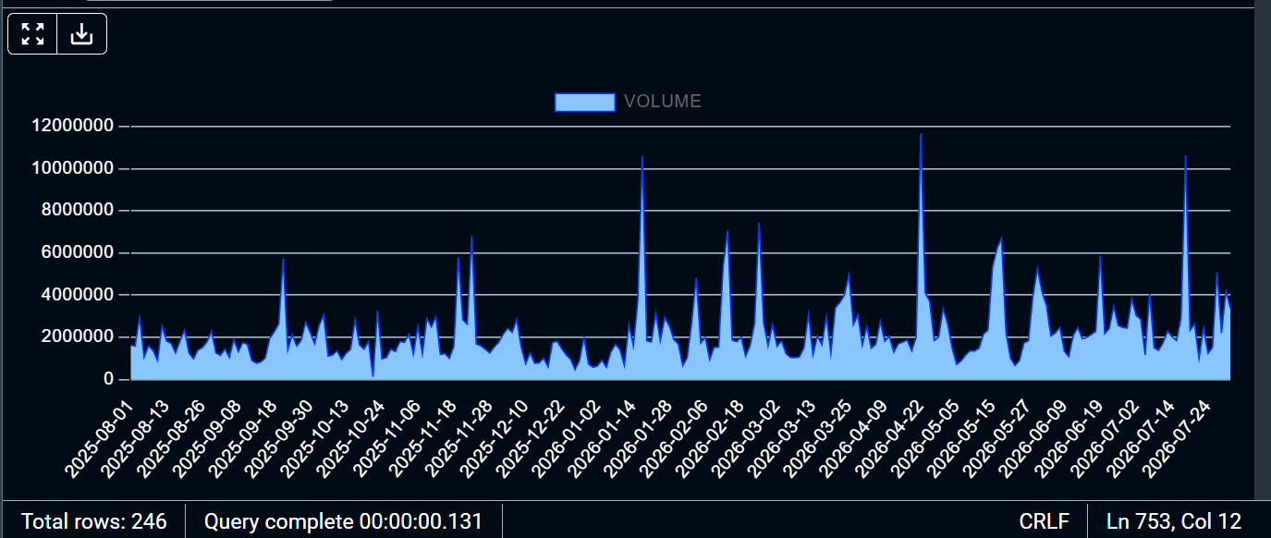

– RUNNING TOTAL ANALYSIS

QUERY 30 – MOVING AVERAGE ANALYSIS
Purpose:
Calculate the moving average of the closing price.

Result:
The query returned 246 records.

Top Results:
Date | Closing Price | Moving Average
2025-08-01 | 1438.80 | 1438.80
2025-08-04 | 1475.00 | 1456.90
2025-08-05 | 1485.40 | 1466.40
2025-08-06 | 1459.00 | 1464.55
2025-08-07 | 1482.00 | 1468.04

Observation:
The moving average reduced short-term fluctuations and revealed the overall trend of the stock price.

Business Interpretation:
Analysts use moving averages to identify trends, predict future movements, and reduce the impact of temporary market fluctuations.

Skills Used:
- AVG()
- OVER()
- ORDER BY
- ROWS BETWEEN
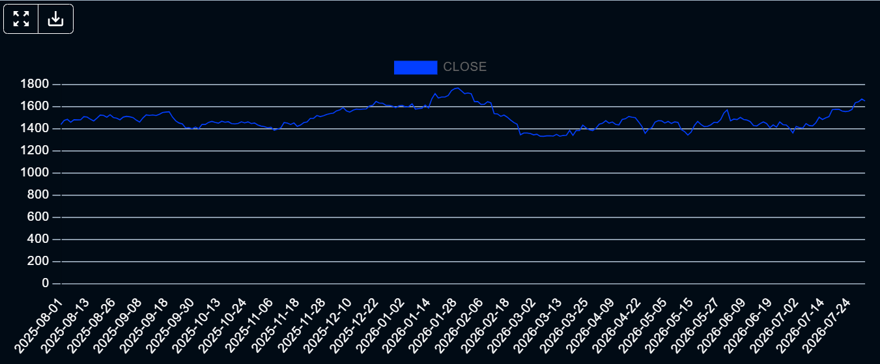

Conclusion :
The analysis revealed important insights into Tech Mahindra's stock performance. Monthly trends, yearly trends, trading volume patterns, price fluctuations, moving averages, and ranking analyses were used to understand the behavior of the stock market. SQL was used extensively to transform raw data into meaningful business insights.

